Online Appendix for the paper titled “The Mark of Incarceration History: Wealth Accumulation and Credit Scores under the Shadow of Incarceration and Race”

Mónica García-Pérez, Fayetteville State University – Broadwell College of Business and Economics

Sarah Gaither, Duke University – School of Psychology & Neuroscience

William Darity Jr., Duke University – Sanford School of Public Policy

Intersection: Racism by Context

Section title: Police and Criminal Justice

Appendix 1: The National Asset Scorecard for Communities of Color (NASCC)

The National Asset Scorecard for Communities of Color (NASCC) was developed in 2014 to address a research gap in data collection on U.S. household wealth. Because traditional wealth national datasets do not collect wealth-related data “disaggregated in detail by race and ethnicity at local levels,” (Kijakazi, et al. 2016, pg. 42) we know little about the asset and debt positions of particular fast-growing and key racial/ethnic subgroups in targeted areas. In 2017, the NASCC initiative expanded the original list of targeted metropolitan areas (Miami, Tulsa, DC, Los Angeles, and Boston) to include the city of Baltimore, Maryland. Its selection coincided with the 2015 death of Freddie Gray and the subsequent uprising in the city. The original NASCC goal was to collect data on wealth inequalities (assets and debts) across racial/ethnic groups in localized areas. The areas were chosen based on their representation of hard-to-reach racial/ethnic groups and their geographic distribution. Depending on the location, further disaggregation was applied to the ancestry background questionnaire.
Conducted by the Cook Center of Social Equity at Duke University, the 2017 Baltimore Project expanded its focus to evaluate the ever-incarcerated population. The primary research question for the Baltimore Incarceration Study conducted by the Cook Center of Social Equity at Duke University was as follows: What is the financial situation for African American and White households with individuals who have been incarcerated, compared to those without an incarceration history? The study looked at the familial-incarcerated households versus the familial-non-incarcerated households by race. The final sample for this study was 254 respondents (155 African American and 99 White respondents). Additionally, in contrast to previous NASCC surveys, the goal of this study was to make a second contact with those who responded to the first phase, the Baltimore telephone interview, and request information about their FICO credit scores and basic details regarding their high school education.
As a new phase of the Baltimore study, the purpose was to contact participants who had responded to the prior telephone interview and request their reported FICO credit score. Additionally, the survey questionnaire included six brief questions related to the respondent’s education. The survey for this phase contained six questions (see online appendix 2) that requested direct information about the participants’ FICO credit score, the year they started and finished high school, and the state and city in which they attended high school.
Individuals were approached via email or postal mail and were given the option to respond online, by email, or by regular mail. Some individuals were approached by phone, but no respondent from the first phase of the survey was contacted more than three times. Participants were offered a gift card to complete the survey. To increase the response rate, the incentive amount was increased during the final stage of data collection. Twelve of the 51 participants who responded received this increased-value gift card.

Response rate and sample analysis
The majority of respondents completed the survey online. Table 1 shows the disaggregation by type of response, from which we computed the response rate using the AAPOR Outcome Rate Calculator (shown in Table 2). Forty individuals originally agreed to respond to the survey but never did. They are considered implicit refusals. Meanwhile, there was no contact information for 55 individuals, and 57 never answered our attempts to reach them.
 | Agreed but did not respond | Never  Answered | Wrong # or Disconnected | Refused | Responded | Total
Responded by Electronic Survey/email |  |  |  |  | 34 | 34
Responded by Letter & phone |  |  |  |  | 17 | 17
Total | 40 | 57 | 55 | 51 | 51 | 254
Table 1: Disaggregated survey response
Note: Most of the respondents answered the survey electronically or by regular mail.

Although the response rate as calculated by AAPOR is 20.1%, we must be cautious about reporting this rate as the final rate. Emails and letters were sent to everyone with contact information from Phase I, with an assumption that this sample was the baseline group. However, the Phase I sample is a combination of four different target groups. The sampling design attempted to find a sample that was representative of each target subgroup. Because of the difficulty of finding the target population due to its size and the similarities to what researchers call “hidden population,” The sample from Baltimore Phase I is not representative of the Baltimore city population. A “hidden population” is considered as such because individuals from that population do not disclose their information due to stigma, limitations, or other barriers. Therefore, another indicator that would help determine the response rate would separate responses by target group and estimate the response rate for each group separately. However, we did not have access to that level of detail in the survey responses. In the Comparison of Samples section, we explore a simplified version of this indicator that estimates the proportion of respondents by each subgroup.
Table 2: AAPOR’s response rate
Response Rate
I=Complete Interviews  P=Partial Interviews  R=Refusal and break off  NC=Non Contact  O=Other  UH=Unknown Household  UO=Unknown other  I/((I+P) + (R+NC+O) + e(UH+UO) ) | 0.201

Overview of the Baltimore Project Phase I Sample Design
To understand the sample we are using in this analysis, we need to offer more details about how the first phase was designed and how that impacts our study. In general, to be eligible, individuals had to live in the city of Baltimore, be 18 years or older, and have a household member or themselves with a history of conviction or have spent more than 30 days in jail, prison, or a youth correctional facility. The focused question of this project was: What is the financial situation for African American and white households with individual(s) who have been incarcerated, compared to those without an incarceration history?
There were four sub-groups defined as follows:
- Never-incarcerated history white (NIW)
- Never-incarcerated history black (NIB)
- Ever-incarcerated history white (EIW)
- Ever-incarcerated history black (EIB)
Further, to avoid confusion, the definition of households was included in the text of the survey instrument: “I’d now like to ask about the people who live with you in your household. We are interested specifically in the people who live together as a family unit sharing income and expenses. This should also include people who would normally live in the household but are away for some reason such as school, the military, or prison.”
An additional clarifying note excluded roommates and boarders from the definition of household members. Another note to keep in mind is that, although the survey was compiled at the individual level, the questions about incarceration history were actually collected at the household level. Wealth information was also computed at the household level, but credit score values and self-reported race were submitted at the individual level.
Because of the lack of baseline information on the ever-incarcerated population in Baltimore, the sample from Phase I didn’t have a target population besides the targeted sub-groups defined in the project. The final sample was intended to represent each category as accurately as possible, but it failed to represent either the total ever-incarcerated population or the full population in Baltimore. The sample frame first consisted of a traditional RDD approach using cell phone numbers (a random sample of 43,707 cell phone numbers) that identified individuals living in the city and oversampled low-income households. However, this attempt did not capture a sufficient number of incarcerated sample targets. Acknowledging that the incarcerated population is considered a hard-to-survey population, the researchers employed a non-probability method that utilized social media (Facebook) to recruit individuals who met the eligibility criteria: race and incarceration history. For this last approach, 34 interviews were completed. The recruitment and interviews of new candidates stopped when (1) the study’s target for ever-incarcerated blacks was reached and (2) none of the remaining respondents were ever-incarcerated whites. The AAPOR response rate was 6.7%, with a final sample size of 254 respondents: eighty-two never-incarcerated blacks, seventy-one never-incarcerated whites, seventy-three ever-incarcerated blacks, and twenty-eight ever-incarcerated whites. Due to its limited size, it is reported that this final group was the most challenging one from which to retrieve a sample.
In the phase used in this study, Phase II, we evaluate the distribution within each subgroup by category and compare these distributions of the sample in Phase I against the Phase II sample. While we cannot say anything about the proportion of these categories with respect to the population (either the total or the ever-incarcerated) in the city of Baltimore because the actual population data doesn’t exist for our time period, our best-educated guess is to assume that the Baltimore Phase I sample is the best representation of each sub-population and to thus compare the responses from Phase II’s samples against Phase I’s samples.

Comparison of samples
Our strategy for sampling weight estimation and to use a statistical baseline to compare and conduct our analysis, we assumed that the sample from Baltimore Phase I represents the actual population distribution for each subgroup, and under this assumption, estimated sampling weights for each group. Effectively, we assumed that each sub-sample represents a different independent population. Ideally, a sample should be a smaller representation of the population and thus display the same distribution as the original population. In practice, however, issues such as non-response and self-selection can lead to sample bias and misrepresent certain population subgroups. To correct for these issues, we compare the Phase II sample distribution against the Phase I sample distribution across individual level information, such as age, family income, sex, education, marital status, employment status, openness to respond to the survey, self-reported bad financial status, use of non-traditional financial institutions, and missing bill payments, and having bank accounts or some debts, that were reported by individuals in Phase I’s survey.
Table 3 shows the number of responses from Phase I and Phase II for each group. The groups without an incarceration history have the largest number of respondents in Phase I. However, in Phase II, never-incarcerated whites and ever-incarcerated blacks have the highest number of respondents. The sampling fraction of never-incarcerated blacks represents the smallest fraction of the four groups (about 11%), whereas the ever-incarcerated whites show the highest sampling fraction (32%).

Table 3: Number of completed interviews by race and incarcerated status
 |  | Number of respondents
 |  | Phase I | Phase II | %
Never-incarcerated history | White | 71 | 16 | 22.5
 | Black | 82 | 9 | 11.0
Incarcerated history | White | 28 | 9 | 32.1
 | Black | 73 | 17 | 23.3
TOTAL |  | 254 | 51 | 20.0
Note: Incarcerated status is defined as someone in the household who is either currently incarcerated or has been incarcerated in the past. Five respondents from Phase I did not have contact information available. Fourteen respondents from Phase I selected more than one race; this study uses the chosen first race. Only two respondents who selected more than one race responded to the Phase II questionnaire.

Appendix 2 Survey Instruments and invitations
Baltimore
NASS Qualtrics: Credit Score Email
Greetings from Duke University

About a year ago, you participated in a research study for Duke University. We called you to ask questions to help us understand how people manage their financial resources during and after the recession. Thank you so much for your previous participation!
We are now interested in investigating the general accuracy of credit scores. We are contacting you to invite you to take part in a paid ($45) follow-up study that should only take a few minutes of your time, since this time there are only a few questions in the survey.
Key Information:
We want to link the information that you gave us in the first survey with your credit score in the last year to evaluate how precise or accurate your credit score may or may not be. If you choose to take part in this study by providing us with your credit score within 10 days of receiving this email, you will receive a Visa or Amazon gift certificate for $45.00 by email or regular mail, and it will be sent to you within 10 -15 business days after we receive your response.
If you agree to participate, you should know the following:
- Your decision to participate and your answer will not affect your credit score.
- Your data will be kept confidential. Your name will not be associated with the research findings from this study.
- De-identified information collected in this study may be made public or used for future research purposes.
- Only the principal investigators and the research team will have access to your data.
- You may withdraw at any time before the data have been analyzed and published.
- In the survey, you will be asked to upload a screenshot or document showing your credit score.
If you don’t know your credit score, the link below gives you options to access your credit score (FICO) for free. If you do not have access to a computer or you need additional assistance accessing your credit report, please contact .
This study is funded by the Washington Center for Equitable Growth.
We appreciate and value your participation at your earliest convenience.
Thank you for your time.

The easiest way to get your FICO score is through Discover (Link below). You don’t need to be a client and you don’t need to enter a credit card number. I am also attaching a document with other options to get your credit score.
https://www.creditscorecard.com/login
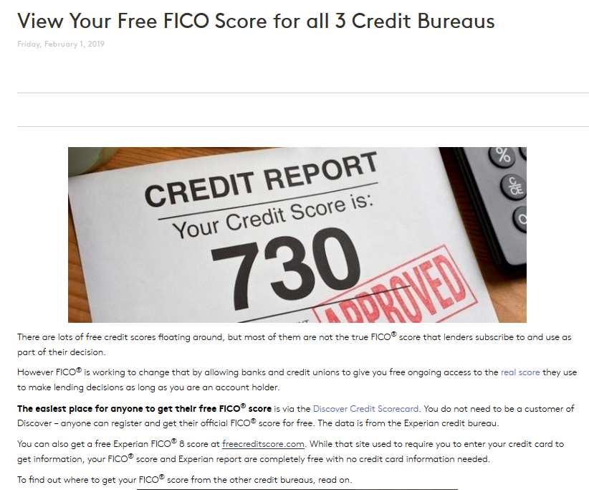

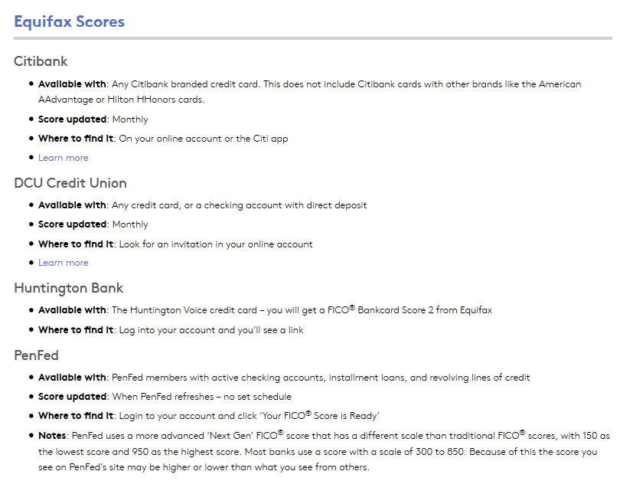

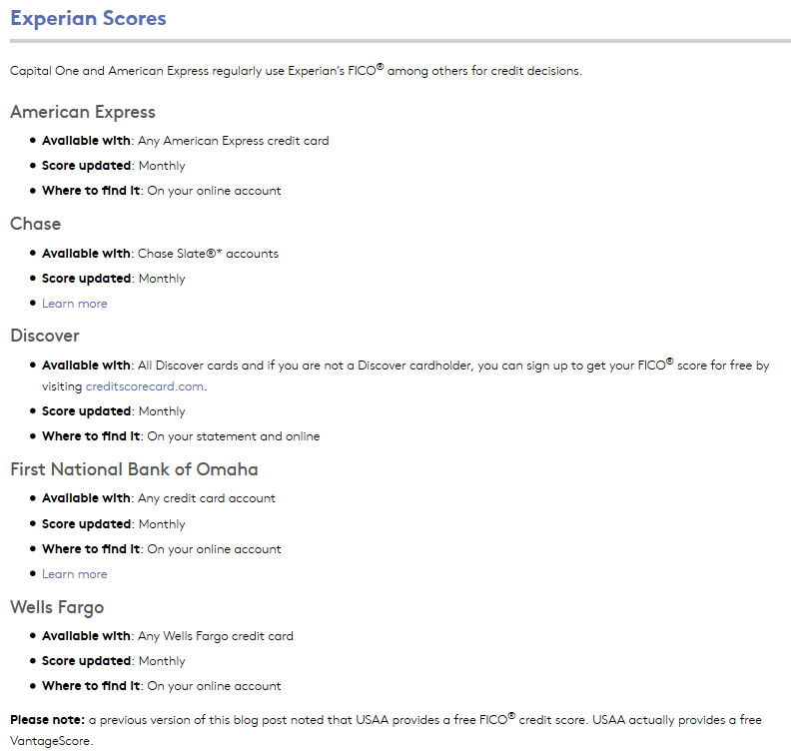
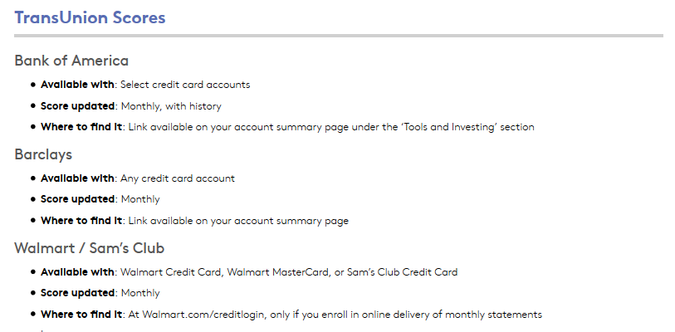

Q1.1 Baltimore NASCC- Credit Score
Welcome to the research study!
Greetings from Duke University,
We are contacting you to invite you to take part in a paid ($45) follow-up study that should only take a few minutes of your time. We want to link the information that you gave us in the first survey with your credit score in the last year to evaluate how precise or accurate your credit score may or may not be. If you choose to take part in this study by providing us with your credit score within 10 days of receiving this email, you will receive a Visa or Amazon gift certificate for $45.00 by email or regular mail, which will be sent to you within 10-15 business days after we receive your response.
Key Information
If you agree to participate, you should know the following:
- Your decision to participate and your answer will not affect your credit score.
- Your data will be kept confidential. Your name will not be associated with the research findings from this study.
- Only the principal investigators and the research team will have access to your data.
- You may withdraw at any time before the data have been analyzed and published.
- De-identified information collected in this study may be made public or used for future research purposes.
- In the survey, you will be asked to upload a screenshot or document showing your credit score.
- If you don’t know your credit score, the email you received from us, gives you options to access your credit score (FICO) for free.

If you do not have access to a computer or you need additional assistance accessing your credit report, please contact .
This study is funded by the Washington Center for Equitable Growth. If you have questions or concerns about this study, you can contact the principal investigators at Duke University.
If you have questions about your rights as a research participant, please call the Duke University Institutional Review Board (IRB) during normal business hours.
We appreciate and value your participation at your earliest convenience.
Thank you for your time.
- I consent to take part in this study. (4)
- I do not consent; I do not wish to participate in the study. (5)
Skip To: End of Block If Welcome to the research study! Greetings from Duke University, We are contacting you to invi... = I do not consent; I do not wish to participate in the study.

Q1.2 To help us understand, the context in which you have lived, please answer the following questions:

Q1.3 In what year did you start high school? If you did not attend high school, please tell us the year you started middle School.
- Year (16) ________________________________________________
- State (19) ________________________________________________
- City (20) ________________________________________________

Q1.4 In what year did you graduate from high school? If you did not graduate or did not go to high school, please tell us the year you stopped attending school.
- Year (16) ________________________________________________
- State (19) ________________________________________________
- City (20) ________________________________________________

Page Break
Q1.5
Do you have a credit history?
- Yes (1)
- No (2)

Skip To: End of Block If Do you have a credit history? = No
Skip To: Q1.6 If Do you have a credit history? = Yes

Page Break

Q1.6 What is the number of your last FICO credit score in the last 12 months?
Note: There is a credit score called, VantageScore. That is not the score that we are requesting. Please verify that your score is called FICO.

________________________________________________________________

Page Break
Q1.7
Please upload in the box below a pdf or a screenshot of your FICO score.
After you click inside the box, a window to select your document will open. If you made a mistake uploading the incorrect document or screenshot, double click the box again and select the correct one.

Page Break
Q1.8 What kind of gift card would you like to receive?
- Visa (1)
- Amazon (2)

End of Block: Block

Baltimore
END OF QULATRICS SURVEY MESSAGE
We thank you for your time spent taking this survey!
Your response has been recorded.
Within a few minutes, you will receive an email to which you can reply, if you want us to send your gift certificate to an address other than the email that we have on file for you.

Baltimore
THANK YOU, EMAIL (Sent after survey completion).
Dear participant,
Thank you again for responding to our survey. The gift certificate you selected, Visa or Amazon, will be sent to the email address we have on file within 10 – 15 days business days. If would like us to send it to a different email or physical address, please reply to this email, and let us know where you prefer us send you the gift card.
We sincerely appreciate you taking the time to answer our questions.
Respectfully,
Baltimore
NASS Qualtrics: Credit Score Letter
Greetings from Duke University
About a year ago, you participated in a research study for Duke University. We called you to ask questions to help us understand how people manage their financial resources during and after the recession. Thank you so much for your previous participation!
We are now interested in investigating the general accuracy of credit scores. We are contacting you to invite you to take part in a paid ($45) follow-up study that should only take a few minutes of your time, since this time there are only a few questions in the survey.

Key Information
We want to link the information that you gave us in the first survey with your credit score in the last year to evaluate how precise or accurate your credit score may or may not be. If you choose to take part in this study by providing us with your credit score within 10 days of receiving this email, you will receive a Visa or Amazon gift certificate for $45.00 by email or regular mail, and it will be sent to you within 10- 15 business days after we receive your response.
If you agree to participate, you should know the following:
- Your decision to participate and your answer will not affect your credit score.
- Your data will be kept confidential. Your name will not be associated with the research findings from this study.
- Only the principal investigators and the research team will have access to your data.
- You may withdraw at any time before the data have been analyzed and published.
- De-identified information collected in this study may be made public or used for future research purposes.
- You will be asked to send this document with your signature to give consent to participate in the study and a copy of your credit score in the stamped envelope provided.
- You also have the option of completing the survey online. For the online survey, you will need to upload a photo or screenshot of your FICO credit score.

If you don’t know your credit score, the link below gives you options to access your credit score (FICO) for free. If prefer to take the survey electronically, do not have access to a computer or you need additional assistance accessing your credit report, please contact .
This study is funded by the Washington Center for Equitable Growth. If you have questions or concerns about this study, you can contact the principal investigators.
If you have questions about your rights as a research participant, please call the Duke University Institutional Review Board (IRB) at during normal business hours.

We appreciate and value your participation at your earliest convenience. Thank you.

Key Information
If you agree to participate, you should know the following:
- Your decision to participate and your answer will not affect your credit score.
- Your data will be kept confidential. Your name will not be associated with the research findings from this study.
- Only the principal investigators and the research team will have access to your data.
- You may withdraw at any time before the data have been analyzed and published.
- De-identified information collected in this study may be made public or used for future research purposes.
- You will be asked to send this document with your signature to give consent to participate in the study and a copy of your credit score in the stamped envelope provided.
- You also have the option of completing the survey online. For the online survey, you will need to upload a photo or screenshot of your FICO credit score.
Please sign below if you agree to participate and send us this letter with a copy of your credit scored in the stamped envelope provided.
I consent to take part in this study Date___________
_______________________________________________________________
1. In what year did you start high school? If you did not attend high school, please tell us the year you started middle School.
Year ________________________________________________
State ________________________________________________
City ________________________________________________

2. In what year did you graduate from high school? If you did not graduate or did not go to high school, please tell us the year you stopped attending school.
Year ________________________________________________
State ________________________________________________
City ________________________________________________

3. What is the number of your last FICO credit score in the last 12 months?
Note: There is a credit score called, VantageScore. That is not the score that we are requesting. Please verify that your score is called FICO.
________________ (Should be three digits only)

Q1.8 What kind of gift card would you like to receive? ⃝ Visa ⃝ Amazon

Please sign below if you agree to participate, send us this letter and a copy of your credit scored in the stamped envelope provided.
I consent to take part in this study. ____________________________________________________

Appendix 3: Survey Response Bias and Comparison Tables

Table A3.1: Comparative summary statistics by sample and sub-population (Full Sample vs. Credit Score Sample)
 | Phase I: Full Sample |  |  |  | Phase II: Credit Score Sample
 | Non-incarcerated history |  | Incarcerated history |  | Non-incarcerated history |  | Incarcerated history
 | White (NIW) | Black (NIB) | White (EIW) | Black (EIB) | White  (NIW) | Black  (NIB) | White  (EIW) | Black (EIB)
N | 71 | 81 | 28 | 71 | 16 | 9 | 9 | 17
Age
Mean | 51 | 48 | 48 | 47 | 49 | 50 | 47 | 42*
Median | 52 | 48 | 49 | 49 | 48 | 49 | 49 | 37*
Family Income
Mean | 92,804 | 38,416 | 37,206 | 27,565 | 134,692 | 62,707 | 43,047 | 28,134
Median | 80,000 | 27,000 | 20,800 | 16,500 | 130,000 | 50,000 | 21,600 | 25,000
Percentages (%)
Female | 48 | 32 | 71 | 45 | 69 | 44 | 78 | 6***
High School Dropout | 6 | 15 | 25 | 26 | 0*** | 11 | 11 | 18
Never married | 32 | 52 | 43 | 51 | 25 | 56 | 44 | 35
Employed | 77 | 51 | 43 | 37 | 88 | 56 | 56 | 35
No 'openness' responding survey | 15 | 13 | 7 | 16 | 19 | 11 | 0*** | 0***
Self-reported bad financial status | 24 | 59 | 75 | 75 | 6 | 67 | 78 | 77
Use of non-traditional financial institutions | 7 | 24 | 21 | 26 | 0 | 22 | 33 | 47
Missing any bill payment | 20 | 54 | 36 | 68 | 0 | 67 | 44 | 88
Have Checking account | 92 | 74 | 71 | 49 | 100*** | 78 | 67 | 58
Have Savings account | 76 | 50 | 41 | 38 | 87 | 78 | 33 | 53
Own a house | 68 | 34 | 32 | 14 | 81 | 56 | 22 | 12
Own a car | 86 | 52 | 61 | 27 | 94 | 78 | 67 | 47

Source: NASCC survey, author’s calculations. The difference in mean/median/proportions as compared to the target population (Phase I Baltimore sample) is statistically significant at the 1%, 5%, or 10% significance level (***, **, * respectively). Robust/bootstrap standard errors.

Table A3.2: Marginal effects from the probabilistic model (Probit model)
Variables | NIW | NIB | EIW | EIB
Family Income | 0 | 0.000* | 0 | 0.000*
 | [0.000] | [0.000] | [0.000] | [0.000]
Female | 0.144 | 0.128 | 0.233 | -0.465***
 | [0.105] | [0.110] | [0.523] | [0.105]
High School Graduate | 0.266 | -0.085 | -0.189 | -0.052
 | [0.260] | [0.210] | [0.540] | [0.165]
Some or College plus | 0.383 | -0.139 | 0.281 | 0.111
 | [0.304] | [0.232] | [0.707] | [0.166]
Employed | 0.08 | -0.073 | 0.117 | -0.094
 | [0.149] | [0.098] | [0.645] | [0.156]
Not openness | -0.047 | 0.037 | -0.497 | -0.359**
 | [0.185] | [0.180] | [0.585] | [0.148]
Good Finance | -0.225 | -0.871*** | 0.337
 | [0.158] | [0.097] | [1.083]
Bad Finance | -0.363** | -0.691*** | 0.628 | -0.071
 | [0.176] | [0.148] | [0.904] | [0.134]
Poor Finance | -0.301 | -0.779*** | 0.362 | 0.076
 | [0.236] | [0.099] | [1.036] | [0.118]
Debt non-tradition institutions | -0.192 | -0.008 | 0.294 | 0.065
 | [0.211] | [0.098] | [0.449] | [0.122]
Saving | -0.193 | 0.08 | -0.544 | 0.078
 | [0.151] | [0.081] | [0.786] | [0.132]
Checking | 0.220* | 0.045 | 0.037 | 0.012
 | [0.131] | [0.101] | [0.539] | [0.202]
Constant | -0.081 | 0.861*** | -0.373 | 0.404***
 | [0.256] | [0.226] | [0.973] | [0.151]
Observations | 62 | 68 | 25 | 58
R-squared | 0.283 | 0.237 | 0.351 | 0.42

Note: Author’s calculation using NASCC data from Baltimore Project Phase I and Phase II. *** p<0.01, ** p<0.05, * p<0.1. Robust/bootstrap standard errors. Never-incarcerated White households (NIW), Never-incarcerated Black households (NIB), Ever-incarcerated White households (EIW), and Ever-incarcerated Black households (EIB).

Table A3.3: Weighted Summary Statistics (Credit Score Sample)
 | Weighted: Credit Score Sample
 | Non-incarcerated familial history |  | Incarcerated familial history
Households | White | Black | White | Black
Observations | 16 | 9 | 9 | 17
FICO score (1) | 791 | 698^ | 621^ | 573^
Age
Mean | 51 | 50 | 47 | 40^
Median | 51 | 49 | 49 | 36^
Family Income
Mean | 147,228 | 79,181^ | 44,033^ | 33,881^
Median | 132,000 | 95,000^ | 21,600 ^ | 38,000 ^
Percentages (%)
Female | 75 | 36’ | 72 | 6^
High School Dropout | 0 | 4’ | 6’ | 17^
Never married | 19 | 36’ | 56^ | 29
Employed | 88 | 79 | 60^ | 46^
No 'openness' responding survey | 25 | 4’ | 0^ | 0^
Self-reported bad financial status | 1 | 53^ | 78^ | 76^
Use of non-traditional financial institutions | 0 | 19^ | 47^ | 47^
Missing any bill payment | 0 | 40^ | 57^ | 87^
Have Checking account | 100 | 93 | 67^ | 74
Have Savings account | 88 | 93 | 33^ | 69^
Own a house | 88 | 77’ | 19^ | 14^
Own a car | 99 | 93 | 75^ | 64^
Source: NASCC survey, author’s calculations. (1) Only for individuals with FICO scores. ^, ‘, * represents the difference in mean/median/proportions as compared to non-incarcerated history white families is statistically significant at the 1% or 5%, significance level, respectively. Robust/bootstrap standard errors.
Table A3.4: Asset holdings and FICO credit scores by group
Group | Any Asset |  |  | FICO
 | Proportion | Difference wrt. NIW | SE | Average | Median | N
NIW | 100 | 0 | 0 | 791 | 808 | 16
NIB | 93 | -7.3 | 7 | 698*** | 739*** | 8
EIW | 80 | -23.4** | 17.9 | 621*** | 564*** | 7
EIB | 82 | -25.8*** | 10.2 | 573*** | 560*** | 14
 | Liquid Assets |  |  | FICO
 | Proportion | Difference wrt. NIW | SE | Average | Median | N
NIW | 100 | 0 | 0 | 791 | 808 | 16
NIB | 93 | -7.3 | 6 | 708 | 739 | 6
EIW | 67 | -33.4*** | 17.9 | 655 | 650 | 4
EIB | 74 | -25.8*** | 10.1 | 571 | 560 | 8
 | Checking Account |  |  | FICO
 | Proportion | Difference wrt. NIW | SE | Average | Median | N
NIW | 100 | 0 | 0 | 791 | 808 | 16
NIB | 93 | -7.3 | 6 | 708 | 739 | 6
EIW | 67 | -33.4*** | 17.9 | 655 | 650 | 4
EIB | 74 | -25.8*** | 10.1 | 571 | 560 | 8
 | Savings Account |  |  | FICO
 | Proportion | Difference wrt. NIW | SE | Average | Median | N
NIW | 89 | 0 | 0 | 791 | 808 | 13
NIB | 93 | 4.5 | 10.4 | 708 | 739 | 6
EIW | 33 | -55.7*** | 18.8 | 705 | 730 | 3
EIB | 74 | -19.1 | 14 | 575 | 560 | 7
 | Other Financial Assets |  |  | FICO
 | Proportion | Difference wrt NIW | SE | Average | Median | N
NIW | 82 | 0 | 0 | 788 | 802 | 13
NIB | 45 | -36.9 | 25.6 | 725 | 739 | 3
EIW | - | - | - | - | - | -
EIB | - | - | - | - | - | -
 | IRA/ Private Annuity |  |  | FICO
 | Proportion | Difference wrt NIW | SE | Average | Median | N
NIW | 94 | 0 | 0 | 794 | 808 | 13
NIB | 69 | -24.9 | 18.1 | 716 | 739 | 4
EIW | - | - | - | - | - | -
EIB | 41 | -52.8*** | 17.9 | 603 | 571 | 3
 | Home Ownership |  |  | FICO
 | Proportion | Difference wrt NIW | SE | Average | Median | N
NIW | 92 | 0 | 0 | 794 | 808 | 13
NIB | 77 | -15.4 | 15.4 | 754** | 739** | 4
EIW | - | - | - | - | - | -
EIB | - | - | - | - | - | -
 | Car Ownership |  |  | FICO
 | Proportion | Difference wrt NIW | SE | Average | Median | N
NIW | 99 | 0 | 0 | 796 | 808 | 14
NIB | 93 | -6.1 | 6.2 | 723** | 739** | 6
EIW | 75 | -24.2 | 14.8 | 631*** | 564*** | 5
EIB | 73 | -25.7*** | 12 | 583*** | 590*** | 7

Note: Author’s calculation using NASCC data from Baltimore Project Phase I and Phase II. *** p<0.01, ** p<0.05, * p<0.1. Robust/bootstrap standard errors. Weighted results. Never-incarcerated White households (NIW), Never-incarcerated Black households (NIB), Ever-incarcerated White households (EIW), and Ever-incarcerated Black households (EIB). As a rule, this study only reports the statistics for samples with three or more observations.
Table A3.5: Debt holdings and FICO credit scores by group
 | Credit Card Debt |  |  | FICO
 | Proportion | Difference wrt NIW | SE | Average | Median | Respondents
NIW | 32 | 0 | 0 | 804 | 808 | 5
NIB | 73 | 41.6 | 21.4 | 735*** | 739*** | 5
EIW | 40 | 8.4 | 23.2 | 636*** | 650*** | 3
EIB | 64 | 32.7 | 19.7 | 584*** | 590*** | 6
 | Student Loans |  |  | FICO
 | Proportion | Difference wrt NIW | SE | Average | Median | Respondents
NIW | 48 | 0 | 0 | 819 | 815 | 7
NIB | 47 | -0.9 | 26.3 | 713*** | 710*** | 5
EIW | - | - | - | - | - | -
EIB | 38 | -10 | 22 | 551*** | 546*** | 3
 | Medical Bills |  |  | FICO
 | Proportion | Difference wrt NIW | SE | Average | Median | Respondents
NIW | - | - | - | - | - | -
NIB | - | - | - | - | - | -
EIW | - | - | - | - | - | -
EIB | 61 | 61.2 | 15.8 | 592 | 590 | 7
 | Mortgage |  |  | FICO
 | Proportion | Difference wrt NIW | SE | Average | Median | Respondents
NIW | 79 | 0 | 0 | 791 | 802 | 11
NIB | 77 | -1.5 | 18 | 754 | 739 | 4
EIW | - | - | - | - | - | -
EIB | - | - | - | - | - | -
 | Auto Loan |  |  | FICO
 | Proportion | Difference wrt NIW | SE | Average | Median | Respondents
NIW | 71 | 0 | 0 | 796 | 826 | 8
NIB | 31 | -39.8 | 22.5 | 656*** | 607*** | 4
EIW | 54 | -17.3 | 26.3 | 636*** | 650*** | 3
EIB | 83 | 12.1 | 20.9 | 548*** | 546*** | 5
Note: Author’s calculation using NASCC (Baltimore Phase I and II). NIW stands for Non-Incarceration history White, SE for standard errors of the mean differences compared to NIW. *** p<0.01, ** p<0.05, * p<0.1. Robust/bootstrap standard errors. Weighted results. wrt means “with respect to.” Never-incarcerated White households (NIW), Never-incarcerated Black households (NIB), Ever-incarcerated White households (EIW), and Ever-incarcerated Black households (EIB).

Table A3.6: Self-reported financial status and Debt in non-traditional financial services and FICO credit scores by group
 | Self-reported Bad Finance |  |  | FICO
 | Proportion | Difference wrt NIW | SE | Average | Median | Respondents
NIW | - | - | - | - | - | -
NIB | 53 | 51.9 | 22.6 | 711*** | 755*** | 5
EIW | 78 | 76.6 | 14.8 | 603*** | 564*** | 6
EIB | 75 | 73.3 | 14.6 | 556*** | 546*** | 8
 | Debt in non-traditional services |  |  | FICO
 | Proportion | Difference wrt NIW | SE | Average | Median | Respondents
NIW
NIB | - | - | - | - | - | -
EIW | 47 | -27.6 | 17.6 | 558 | 563 | 3
EIB | 46 | -26.9 | 14.4 | 576 | 590 | 4
Note: Author’s calculation using NASCC (Baltimore Phase I and II). NIW stands for Non-Incarceration history White, SE for standard errors of the mean differences compared to NIW. wrt means “with respect to.”Never-incarcerated White households (NIW), Never-incarcerated Black households (NIB), Ever-incarcerated White households (EIW), and Ever-incarcerated Black households (EIB).

Table A3.7: Liquid Assets, Total Assets by group
 | Liquid Assets
Incarceration history | NIW | NIB | EIW | EIB | All | FICO
Average | 77,711 | 4,133 *** | 5,803 *** | 6,354 *** | 30,137 | 710
Median | 32,000 | 4,050 *** | 125 *** | 500 *** | 4,050 | 739
Standard Deviation | 107,723 | 2,786 | 13,601 | 14,201 | 71,058 | 111
Standard Errors | 27,814 | 929 | 4,534 | 3,939 | 10,477 | 20
 | Total Assets
Incarceration history | NIW | NIB | EIW | EIB | All | FICO
Average | 597,568 | 190,080 *** | 81,726 *** | 56,962*** | 270,442 | 703
Median | 600,000 | 174,050 *** | 6,500 *** | 17,800*** | 174,050 | 734
Standard Deviation | 269,950 | 120,465 | 173,600 | 95,655 | 305,245 | 110
Standard Errors | 69,701 | 40,155 | 57,867 | 23,200 | 45,006 | 19
Note: Author’s calculation using NASCC (Baltimore Phase I and II). NIW stands for Non-Incarceration history White, SE for standard errors of the mean differences compared to NIW. *** p<0.01, ** p<0.05, * p<0.1. Robust/bootstrap standard errors. Weighted results. Never-incarcerated White households (NIW), Never-incarcerated Black households (NIB), Ever-incarcerated White households (EIW), and Ever-incarcerated Black households (EIB).

Table A3.8: Non-housing Debts and FICO credit scores by group
 | Non-housing Debt
Non-incarcerated/  incarcerated history | NIW | NIB | EIW | EIB | All | FICO
Average | 29,789 | 34,877 | 24,001 | 60,198 | 36,724 | 704
Median | 20,000 | 2,500 | 0 | 37,200 | 17,000 | 738
Standard Deviation | 31,427 | 44,342 | 50,455 | 127,154 | 72,219 | 113
Standard Errors | 8,114 | 14,781 | 16,818 | 35,266 | 10,648 | 19
FICO (Average) | 796 | 723*** | 635*** | 577***
FICO (Median) | 808 | 739*** | 650*** | 546***
Note: Author’s calculation using NASCC (Baltimore Phase I and II). NIW stands for Non-Incarceration history White, SE for standard errors of the mean differences compared to NIW. *** p<0.01, ** p<0.05, * p<0.1. Robust/bootstrap standard errors. Weighted results. Never-incarcerated White households (NIW), Never-incarcerated Black households (NIB), Ever-incarcerated White households (EIW), and Ever-incarcerated Black households (EIB).
References
Marks, E., & Rhodes, B. (2017). Wealth inequality in Baltimore: Methodology report (RTI Project No. 0215356). RTI International. Mimeo.
Marks, E., & Rhodes, B. (2019). Needles in haystacks and diamonds in the rough: Using probability and nonprobability methods to survey low-incidence populations. Survey Insights: Methods from the Field. https://surveyinsights.org/.
Salganik, M. J., & Heckathorn, D. D. (2004). Sampling and estimation in hidden populations using respondent-driven sampling. Sociological Methodology, 34, 193–240. https://doi.org/10.1111/j.0081-1750.2004.00152.x.

AAPOR (Version 4.0, March, 2016).
A hidden population (or hard-to-reach population) is generally categorized as one that is difficult to categorize in terms of size and characteristics since its identification relies on individuals’ willingness to disclose an unobservable status. Further, if this status is one that is socially stigmatized, individuals would have incentives to avoid disclosing this information due to fear or need of privacy (Salganik and Heckathorn 2004).
Marks and Rhodes (2017 and 2019) offer more details about the sample design of the Baltimore Phase I project (Marks and Rhodes 2017, Marks and Rhodes 2019). We provide a summary here.
Fourteen respondents identified multiple races. Six of these respondents self-identified as white first race, and then African American second race; one respondent self-identified as African American first race, and then as white second race. Due to the small sample, we use the first race as the first identification of race. We maintain information of multiple races as mixed race for future reference and apply it when needed.
See the letter, email message, and consent form and questionnaire in the appendix for more details.
As is the practice in this literature, we report median values in addition to average values when applicable.

